#### **Time series forecasting - ANN**

**INTRODUCTION**

This task aims to forecast an exchange rate for dollars/GBP on August 8, 2020, using a Neural Network model in SPSS. The data set contains daily exchange rates between January 4, 2010 and August 7, 2020, obtained from the Federal Reserve Economic Data (FRED) website. Neural networks are particularly capable of identifying nonlinear trends in time series data and extrapolating a value from the history of a time series.

**VARIABLE SELECTION**

The target (or output variable) is the exchange rate on August 8, 2020. Five lagged exchange rates (as taken from the previous 5 days) were used as input variables, as these variables account for the relevant short-term trends in predictive modelling and noted patterns when investigating autocorrelation.

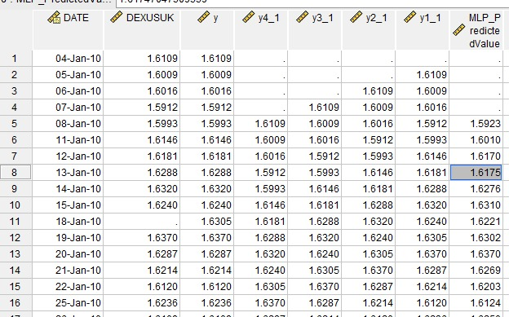

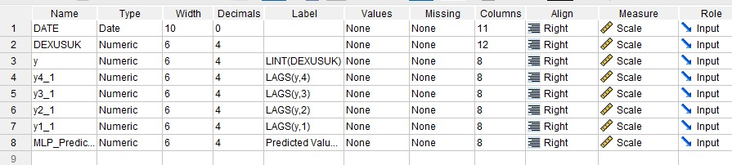

This allowed the selection of input variables that accounted for short-term trends considerably more effectively than longer lagged rates should allow for one-step ahead forecasting.

**MODEL TRAINING**

An MLP (Multilayer Perceptron) model was trained with the following settings:

• input layer with 5 neurons (lags 1 - 5)

• one hidden layer (number of neurons auto-detected by SPSS)

• output layer with 1 neuron (predicted rate).

The sample was divided into training (70 %) and test (30 %). SPSS took care of normalizing the data prior to training.

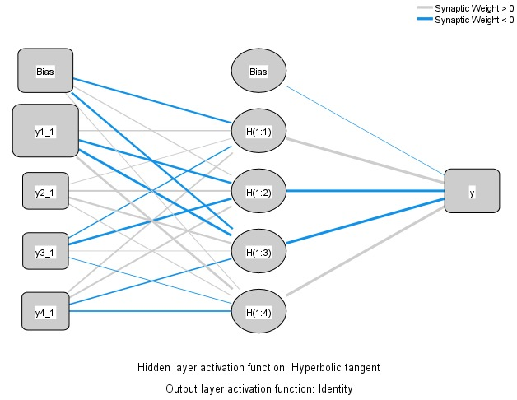

The figure demonstrates the architecture of the model, and how the inputs were passed to the hidden layer so that the output could be produced.

**MODEL PERFORMANCE**In the model summary below, the errors for both training and test sets are displayed**.**

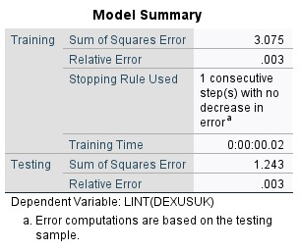

The low relative error shows a high level of performance of the model and generalizability. The low difference between training and test errors show that the model did not overfit the data. Predictor Importance

**PREDICTOR IMPORTANCE**

SPSS provides normalized importance values for the lagged inputs to determine what lagged inputs contributed greatest to the prediction.

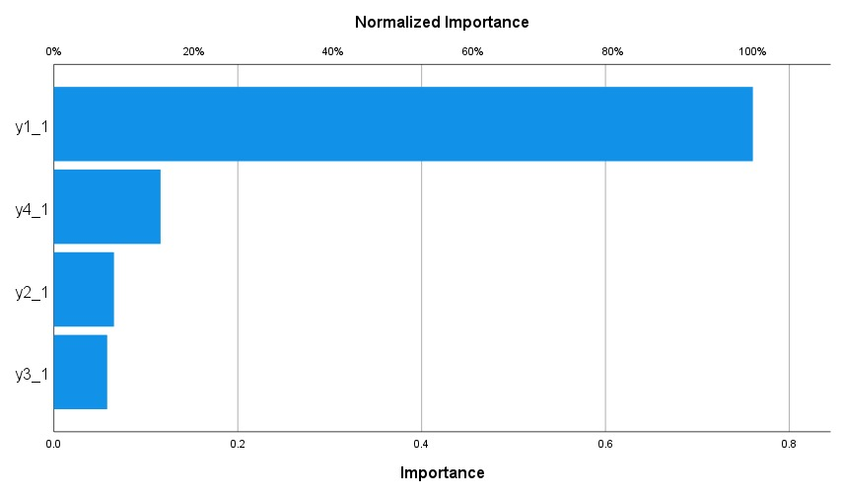

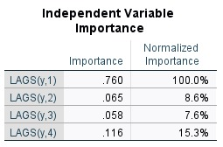

Lag 1 typically shows the highest influence, which aligns with the expectation that yesterday’s rate has the most predictive power.

Lag 1 is usually the largest, as it is typically expected to have the highest influence using yesterday's rate is the best predictor.

**FORECAST VALUE**

The one-step ahead forecast produced using the model on August 8, 2020, is as follows:

Predicted Exchange Rate: 1.3119

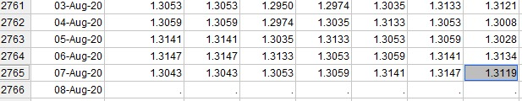

**CONCLUSION**

The neural network model produced a reasonable prediction of the exchange rate on August 8, 2020. The justification in the choice of lagged inputs is shown through the contribution of the lagged input to model performance. The structure of the network, the model performance metrics, and forecast output, shows that this model is appropriate for forecasting short-term exchange rates.